

SUBJECT | AP Mathematics Paper 1 | DATE | 24 November 2015
GRADE | 11 | MARKS | 200
EXAMINER | Mr Gill | MODERATORS | Mrs Povall, Mr Benecke
NAME |  | DURATION | 2 Hours
TEACHER | Benecke / Gill / Povall
QUESTION NO | DESCRIPTION | MAXIMUM MARK | ACTUAL MARK
1 | Algebra | 49
2 | Absolute Value | 32
3 | Functions | 18
4 | Calculus | 58
5 | Radian Measure | 37
6 | Inverses | 6
TOTAL |  | 200

question 1 49 marks
Solve for $x∈C$
a) $\frac{x+1}{(2x+5)(3x-1)}+\frac{x-3}{(3x-1)(3x+1)}=\frac{2x-1}{6x^{2}-x-1}$ (10)
b) $\frac{1}{x+3}-\frac{3}{\sqrt{x+3}}=4$ (10)
c) $\frac{10}{x^{2}+4}<5$ (3)
d) $\frac{2x^{2}+2x}{x+5}-3≥0$ (8)
e) $x^{4}-8x^{3}+6x^{2}+232x-615=0$; Given that $x=5-4i$ is a solution. (10)
f) $\frac{a+3i}{-(11+13i)}=\frac{2-5i}{bi}$ (8)
question 2 32 marks
a) Consider the expression $|x+3|$. Gavin says that $x$ cannot be less than -3 because that would make the expression negative and an absolute value cannot be negative.
Is Gavin correct? Justify your answer (3)
b) Explain why $|x^{2}+5x-3|=-\sqrt{x^{2}+12x+4}$ has no solutions. (2)
c) Solve for $x:$ $|x^{2}+4x|=3$ (6)
d) Sketch the function$f(x)=|2x+3|-1$. Indicate all intercepts and salient / turning points. (5)
e) Sketch the function$g(x)=x^{2}-3|x|+4$. Indicate all intercepts and salient / turning points. (7)
f) Solve the inequality for $x:$ $|x^{2}+3x-10|≤2x+10$ (9)
question 3 18 marks
a) Given $f(x)=3x^{2}+2x-5$, $g(x)=2sin x$ and $h(x)=\sqrt{x}$.
i) Determine $g∘f∘h(4)$ (5)
ii) Determine $f(h(x))$ (3)
b) Given $f(x)=\frac{5}{\sqrt{3x-1}}$, determine functions $g(x)$ and $h(x)$ such that $f(x)=g(h(x))$. (4)
c) Given $f(x)=3x+7$
i) Determine the inverse of $f(x)$. (4)
ii) Is the inverse of $f(x)$ a function? Justify your answer. (2)
question 4 58 marks
a) Evaluate $\lim_{x→3} \frac{3x^{5}+3x^{2}+2x-1}{x+3}$ if the limit exists. (2)
b) Evaluate $\lim_{x→3} \frac{x^{3}-27}{x-3}$ if the limit exists. (4)
c) Evaluate $\lim_{n→∞} \frac{{3n}^{3}+n-2}{n^{3}-4}$ (5)
d) Given $f(x)=\{-3x; x<-5 x^{2}-10; -5≤x<4 \frac{12}{x}; x>4$
i) Determine $\lim_{x→4} f(x)$ if the limit exists (5)
ii) Determine whether $f(x)$ is continuous at $x=-5$. Show all calculations. (7)
e) Consider the function $f(x)$ sketched below. Classify each discontinuity with reference to the limit and value of $f(x)$. You do NOT need to perform any calculations.

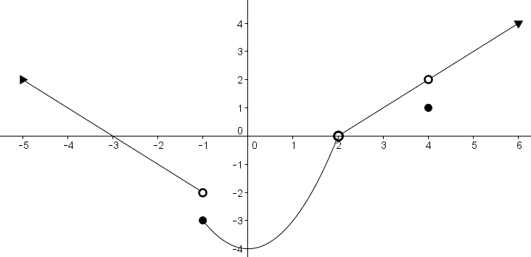

i) Classify the discontinuity at $x=-1$. (2)
ii) Classify the discontinuity at $x=2$. (2)
iii) Classify the discontinuity at $x=4$. (2)

f) Given $f(x)=2x^{2}+3x$, determine $f'(x)$ from first principles (6)

g) Use the rules of differentiation to determine $f'(x)$ if:
i) $f(x)=5$ (1)
ii) $f(x)=3x^{3}-5x^{2}+7x-3$ (3)
iii) $f(x)=\frac{x^{3}-12-3x^{2}+4x}{x-3}$ (5)
iv) $f(x)=(-4x^{2}+3x)(x^{5}-3x^{3}-12)$ (5)

h) Given $f(x)=x^{3}+3x^{2}-5x-2$
i) Determine the coordinates of $f(x)$ at $x=3$. (1)
ii) Determine the gradient of $f(x)$ at $x=3$. (4)
iii) Determine the equation of the tangent to $f(x)$ at $x=3$. (4)

question 5 37 marks

a) Prove the identity $sec x cosecx-cot x =tan x$ (7)

b) Convert the following from radians into degrees.
i) $\frac{5π}{2}$ radians (2)
ii) $\frac{2}{5π}$ radians (2)

c) Convert the following from degrees into radians.
i) $150°$ (2)
ii) $540°$ (2)

d) The diagram below shows the Pacman character. Pacman roams around a maze opening and closing his mouth in order to eat the trail of dots inside the maze.

Pacman is in the shape of a circle with a sector removed. The radius of the circle is 36cm. The angle of the removed sector, representing the mouth, is $θ$ radians, where $θ∈[\frac{π}{6};\frac{π}{3}]$.
- Determine the perimeter when Pacman has his mouth opened to a maximum. (5)
- Determine the maximum area that Pacman occupies. (3)

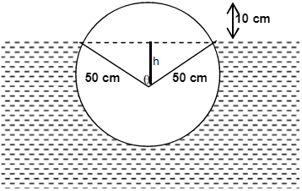
e) The diagram below shows the cross-section of a wooden log floating in water. The log has a radius of 50 cm.

- Explain why $h$, the height of the big triangle, is $40$ cm. (1)
- Calculate the base of the big triangle. (2)
- Show that $θ=1,287$ radians (4)
- What area of the cross-section of the log is below water? (7)

\
question 6 6 marks
Consider the graph drawn. Note that the point (2, 3) is NOT included.
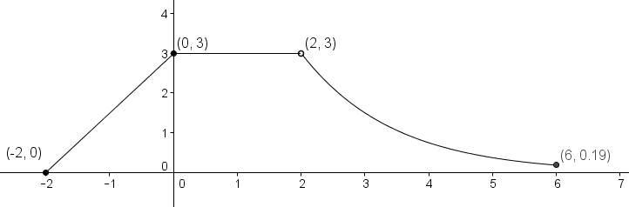
a) Sketch the inverse of the graph. Label the inverse coordinates of the 4 points that have been given in the original. (4)
b) Give the domain of the inverse of the graph. (2)

